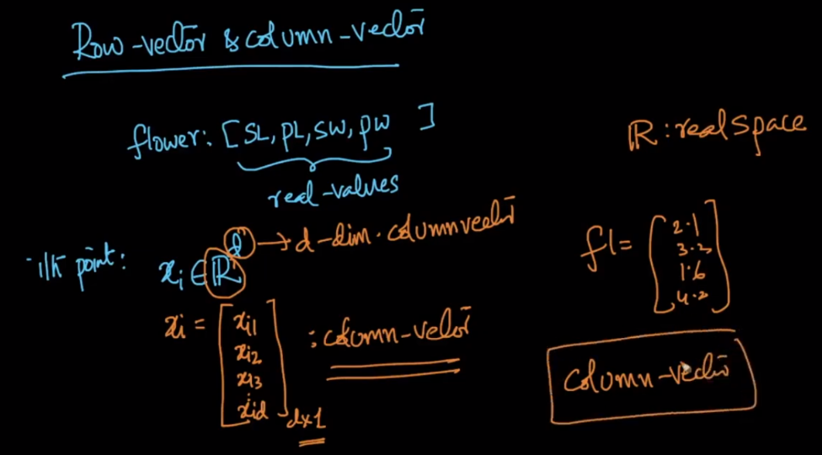

By default Any vector is considered as column vector until it’s explicitly specified as row vector.

Let’s take example of iris dataset, here we have 4 fetaures(columns) and 150 rows,

Each row in that 150th row contains 4 feature’s value, but by default it’s known as column vector in machine, that means for iris we have 150 column vector each with dimension 1*4.

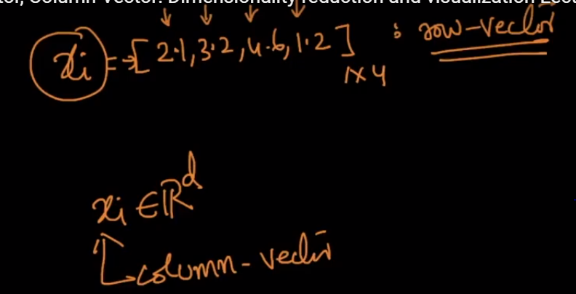

**Comments :**

if you have seen iris dataset, it contains 150 rows and 4 columns.in martix notation represented as (150 * 4). each row in this dataset can be represented as a row vector(i.e lets take example row=5,it has [5.0,3.6,1.4,0.2] means row 5 is of dimension (1 * 4) and has values for sepal length=5.0, sepal width=3.6, petal length = 1.4, petal width=0.2).Vector in machine learning generally means column vector